|  |  |  |  |  |  |  |  |  |  |  |
| --- | --- | --- | --- | --- | --- | --- | --- | --- | --- | --- |
|  |  |  |  |  | **Assignment Cover Sheet** | | | | |  |
|  |  |  |  |  |  |  |  |  |  |  |
|  | **Qualification** | |  |  |  | **Module Number and Title** | | | |  |
|  |  |  |  |  | |  |  | |  |  |
|  | HD in Software Engineering/HD in Network Technology and Cybersecurity | | | | | CSE4005/Database Design Development | | | |  |
|  |  |  |  |  | |  |  | |  |  |
|  | **Student Name & No.** | | | | | **Assessor** | | | |  |
|  |  |  |  |  | |  |  | |  |  |
|  | <to be filled by the student> | | |  | |  | | | |  |
|  |  |  |  |  |  |  |  | |  |  |
|  | **Hand out date** | |  |  |  |  | **Submission Date** | | |  |
|  |  |  |  |  |  |  |  | |  |  |
|  |  |  |  |  |  |  |  | |  |  |
|  |  | |  | | |  |  | | |  |
|  | **Assessment type** | | **Duration/Length of** | | |  | **Weighting of Assessment** | | |  |
|  | Reports 3000 Words | | **Assessment Type** | | | 100% | |  |  |  |
|  |  |  | End of the Module | | |  |  |  |  |  |
|  |  |  |  |  |  |  |  |  |  |  |
|  |  |  |  |  |  |  |  |  |  |  |
|  |  |  |  |  |  |  |  |  |  |  |

**Learner declaration**

I certify that the work submitted for this assignment is my own and research sources are fully acknowledged.

**Marks Awarded**

First assessor

IV marks

Agreed grade

|  |  |  |  |  |
| --- | --- | --- | --- | --- |
|  | Signature of the assessor | Date |  |  |
|  |  |  |  |  |
|  |  |  |  |  |

1

**FEEDBACK FORM**

**INTERNATIONAL COLLEGE OF BUSINESS & TECHNOLOGY**

**Module/Title:** Database Design and Development /Design a Database Management System for “ICE MAN” ice cream sellers

**Student:**

**Assessor:**

**Assignment:**

**Strong features of your work:**

**Areas for improvement:**

**Marks Awarded:**

2

**Course Work**

**Learning outcomes covered**

* LO1 Explain the database concepts and components
* LO 2 Develop a logical database design.
* LO 3 Construct a physical database for a given requirement
* LO 4 Test and Manage databases

**Scenario and the Task**

ICE MAN is a famous ice-cream seller company and the company management wants to create an application to manage their main processes. It sells Ice cream to the customers and customize the ice cream orders. Customers are recorded to ensure better service.

Customers details are recorded as Customer No, Customer Name, Contact Details (Home, Mobile and Email), Address, and NIC. The orders are identified through the order No, Order details and customer no. Order details will contain flavor, additions, quantity …etc. Each order has order status where customer can know whether order is prepared, cancelled or pending. Once the order is completed bill will be calculated. Bill will contain bill no, order no, customer no, cashier no and other relevant details. Once customer can make multiple orders at the sometime and one order can have different types of items. Cashier will login to the system by entering the user name and password. Cashier details are also recorded in the employee table. You may do necessary assumptions.

**Students can add any functionality which will enhance the system and make the proposed solution more comprehensive.**

**Use Harvard referencing to properly acknowledge all the external sources you use.**

**Tasks:**

Design the database with the constraint that the available technology is relational.

|  |
| --- |
| 1. Explain what is data model, critically compare different data models and explain why older data models are being replaced by new data models. **(LO1)** (15 Marks)   A data model is a conceptual depiction of data that specifies the organization, limitations, and connections among data pieces. It offers a structure for managing and organizing data in a systematic way. Hierarchical, network, relational, object-oriented, and NoSQL models are just a few examples of the various types of data models.  Data is arranged in a tree-like shape in hierarchical data models, which are the oldest sort of data models. This format works well for displaying data that has a clear hierarchy, but it can be difficult to use and maintain. Data is arranged as a graph with nodes and edges in network data models, which were created as an enhancement over hierarchical models. Although this paradigm enables more flexible interactions between data items, managing and navigating it can be challenging.  Data is arranged in tables with rows and columns in relational data models, which are now the most used data models. With the help of this model, data may be managed and organized in an easy-to-understand manner. SQL is the query language used by relational databases. The object-oriented programming paradigm, in which data is arranged as objects with properties and methods, serves as the foundation for object-oriented data models. Although it can be difficult to create and administer, this paradigm is appropriate for displaying complicated data with extensive relationships. Large amounts of unstructured data that are organized as key-value pairs, documents, or graphs can be handled using NoSQL data models. High performance and scalability are provided by this model; however it can be complicated.  Newer data models are replacing older ones for a number of reasons, including:   * **Scalability**: In today's data-driven world, it's crucial because older data models may not be able to handle enormous volumes of data. * **Flexibility:** Newer data models offer more adaptable methods of storing and organizing data, allowing for relationships and data structures that are more intricate. * **Performance:** Newer data models have improved performance and scalability, making it possible to analyze data more quickly and effectively. * **Complexity:** Newer data models offer easier and more intuitive ways to organize and handle data than older data models, which can be complicated and challenging to manage. * **Rising technologies:** Newer data models are being created to address rising technologies like big data and cloud computing, which call for unique methods of data management and processing.   Data models offer a conceptual framework for handling and organizing data, to sum it. Newer data models are being created to remedy the shortcomings of existing data models and to manage developing technology, even though there are many distinct types of data models, each with its own strengths and disadvantages. |

1. Analyze and briefly explain the different approaches to database design. **(LO1)** (10 Marks)

There are several approaches to database design, including:

* **Top-down approach:** In this method, the database design is generated from the entire system design by starting with it. The database schema is created to support the functional requirements of the system, which are the main focus. This method works effectively for small to medium-sized systems with clearly specified system designs.
* **Bottom-up approach**: With this method, the database design is created from the data pieces and their connections. The database schema is created to support the system's data requirements, which are the main focus. This method works effectively for large, complicated systems with ill-defined data requirements.
* **Entity-relationship (ER) modeling**: Entity-Relationship (ER) modeling is a graphical method of database design that uses entities, properties, and relationships to model the system's data needs. The system's items are represented by the entities, their characteristics by the attributes, and connections between them by the relationships. For creating relational databases, ER modeling is frequently utilized.
* **Object-oriented modeling**: Object-oriented modeling is a method of database design that models the system's data requirements using object-oriented ideas like inheritance, encapsulation, and polymorphism. This strategy is appropriate for complicated systems that call for an adaptable and extensible data model.
* **Data normalization**: Data normalization is a relational database design method that lessens data duplication and enhances data integrity. By arranging the data into tables that satisfy specific requirements, data normalization aims to eliminate data abnormalities such update anomalies, insertion anomalies, and deletion anomalies.
* **Dimensional modeling**: Data warehouses and business intelligence systems are designed using the database method known as dimensional modeling. The data is divided into facts and dimensions in dimensional modeling, where facts stand in for the business KPIs and dimensions for the attributes that explain the facts.

In conclusion, there are various methods for designing databases, each with distinct advantages and disadvantages. The choice of strategy is determined by the system's specific requirements as well as the database designer's expertise and experience.

1. Draw an entity relationship diagram for given scenario with proper standards. Identify important keys and represent different types of attributes and relationships. **(LO2)** (10 Marks)

1. Draw Relational Schemas. Effectively map conceptual data models with relational database
2. schema according to the mapping algorithm. All the steps should be clearly mentioned. **(LO2)** (10 Marks)

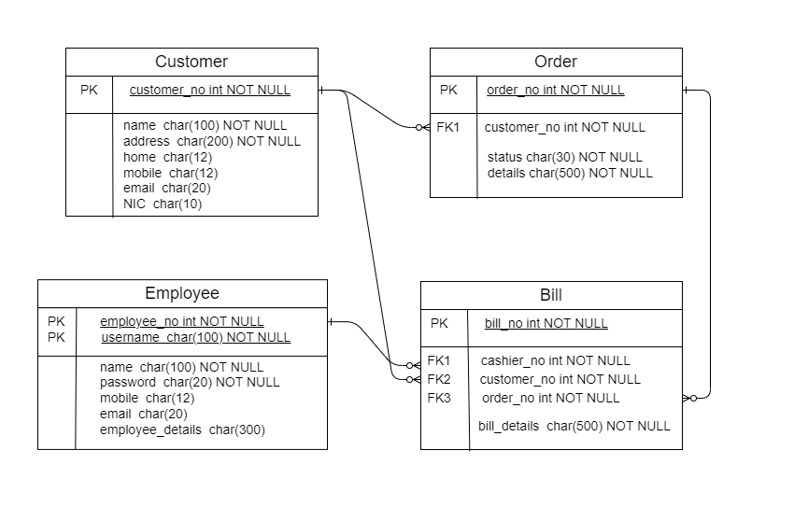

We use a mapping algorithm to convert the conceptual data model into a relational schema, which includes the following steps:

• List all entities and their characteristics.

• List all connections and their fundamentals.

• Make tables for every entity, giving them primary keys.

• Create tables with primary keys for each many-to-many relationship.

• Each table should have foreign keys added to represent the relationships.

Explanation of the schemas:

* The customer_no serves as the primary key in the Customers database, which contains customer information. Customer_name, home_contact, mobile_contact, email_contact, address, and NIC are the additional properties.
* Order_no serves as the primary key in the Orders database, which contains order details. Other attributes include flavor, additives, quantity, order_details, order_status, and customer_no, a foreign key that points to the Customers table.
* Each bill's information are contained in the Bills table, which uses bill_no as its primary key. Order_no and customer_no are additional properties that serve as foreign keys to the Orders and Customers tables, respectively. Cashier_no and other_details are also listed on the table.
* Each employee's information is contained in the Employees table, which uses cashier_no as its primary key. Cashier_name, username, and password are the additional properties. Information about the cashier's login is kept in the table.

1. Create the database using SQL server. **(LO3)**

* Practical submission and Demonstration (15 Marks)
* NOTE: Make sure to enter at least 15 records for each table.
* 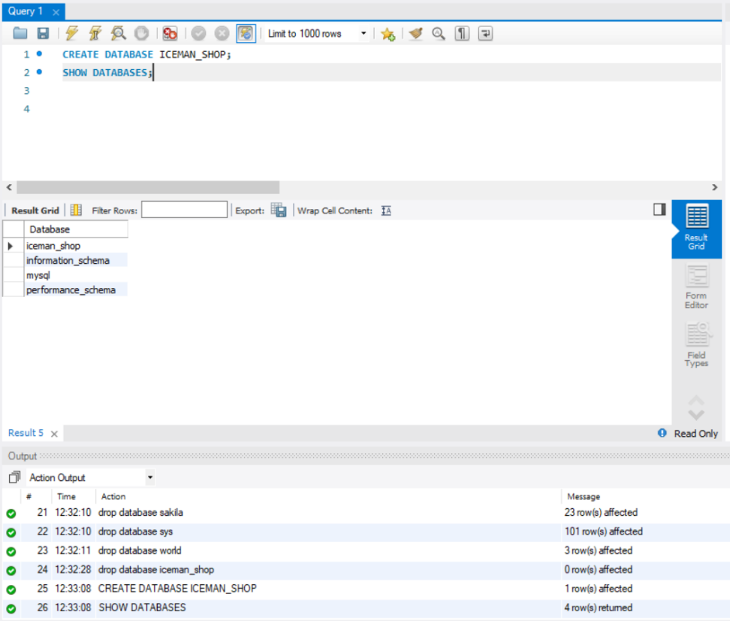Creating the database
* Create tables.

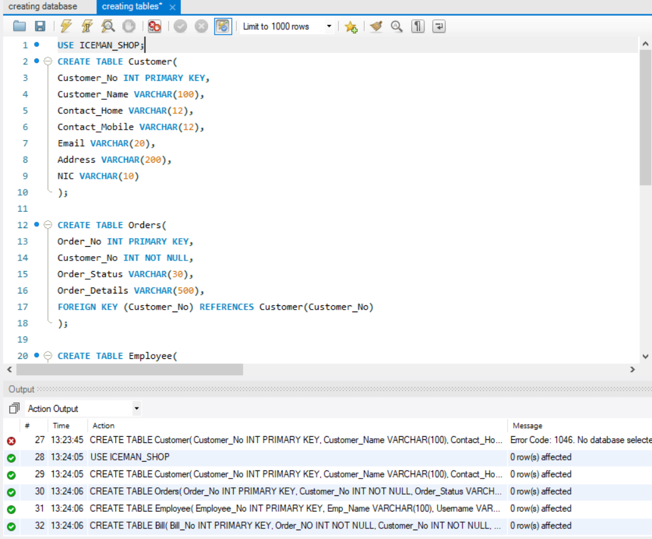

* Populating tables

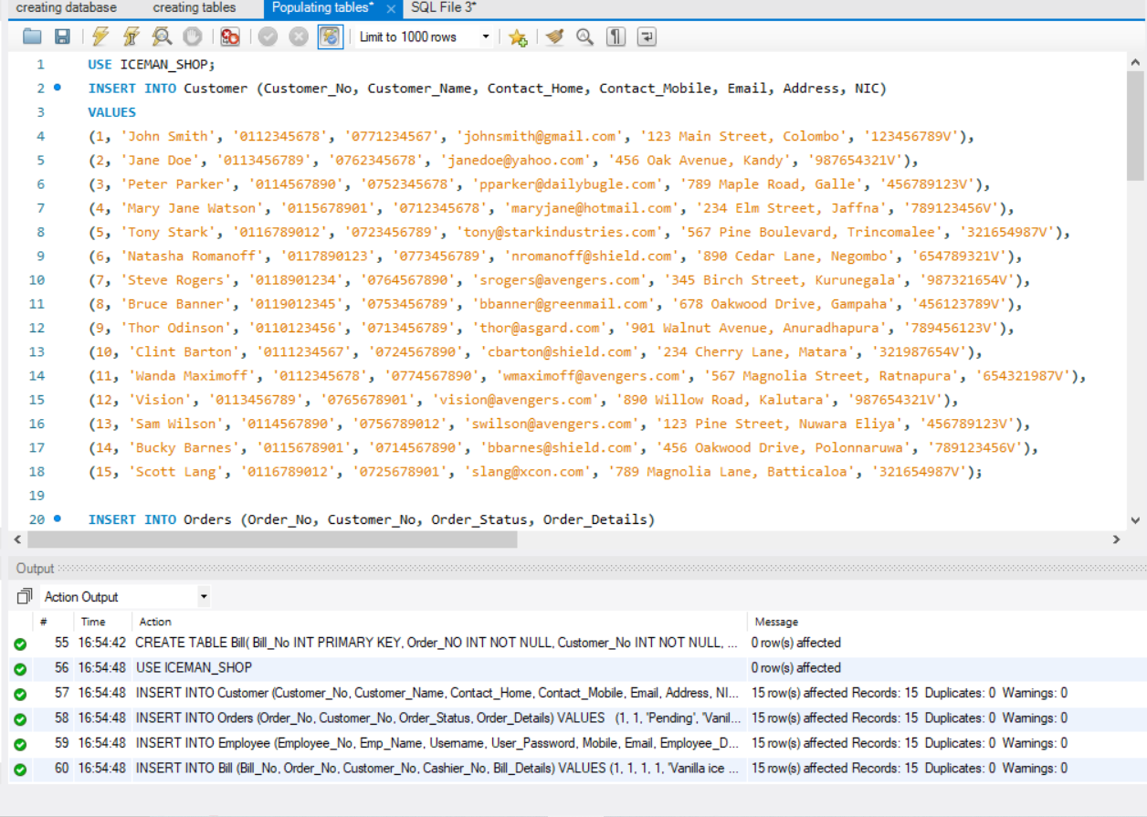

* Extracting data from tables

1. Write SQL queries for below requirements and demonstrate outputs in the report. ( **LO3)** (10 Marks)

* List of items of a particular order

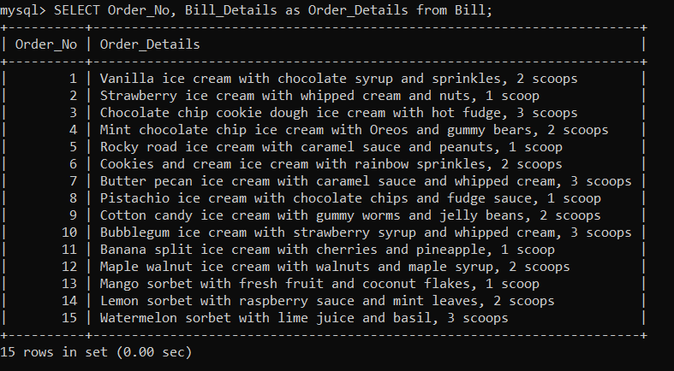

* No of ongoing orders made by a particular customer

* List of customers and their bills

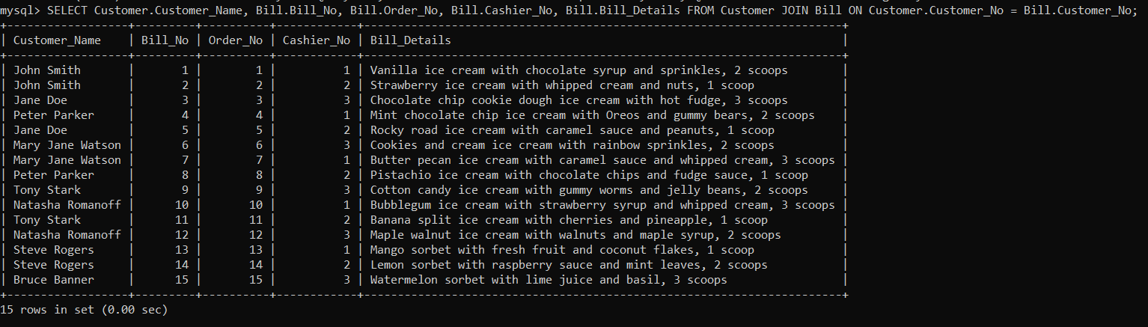

1. Provide the Test plan, test strategy and proper test cases. **(LO4)** (10 Marks)

Here is the test plan for this system.

* Introduction:

This test plan's goal is to confirm the accuracy and effectiveness of the Iceman Shop database system. The test approach, test cases, test objectives, and test scope are all included in the test plan.

* Scope:

This test plan's scope covers testing the database system for the Iceman Shop. The system will be examined in the following areas:

1. Testing the system's functioning

2. Testing the system's performance

* Objectives:

The objectives of this test plan are as follows:

1. To ensure that the system functions correctly and efficiently
2. To ensure that the system meets the requirements of the user
3. To identify any issues or bugs in the system

* Test Strategy:

The test strategy for the Iceman Shop database system will include the following steps:

1. Unit Testing: Each database table will be subjected to unit testing to make sure it is operating properly.
2. Integration Testing: To make sure that all of the database's tables are interacting with one another without any problems, integration testing will be done.
3. System Testing: To make sure the system is operating properly overall, system testing will be done.
4. Performance Testing: Performance testing will be done to make sure the system is responsive and capable of handling the anticipated load.
5. Security Testing: To make sure the system is secure and user data is secured, security testing will be done.

* Test Cases:

The following test cases will be performed on the Iceman Shop database system:

1. Test case name: Customer Information Test

Test objective: To ensure that customer information is stored correctly in the database

Test steps:

* Add new customer information to the database
* Retrieve the customer information from the database
* Verify that the customer information in the database matches the information that was added

1. Test case name: Order Information Test

Test objective: To ensure that order information is stored correctly in the database

Test steps:

* Add new order information to the database
* Retrieve the order information from the database
* Verify that the order information in the database matches the information that was added

1. Test case name: Employee Information Test

Test objective: To ensure that employee information is stored correctly in the database

Test steps:

* Add new employee information to the database
* Retrieve the employee information from the database
* Verify that the employee information in the database matches the information that was added

1. Test case name: Bill Information Test

Test objective: To ensure that bill information is stored correctly in the database

Test steps:

* Add new bill information to the database
* Retrieve the bill information from the database
* Verify that the bill information in the database matches the information that was added

1. Test case name: Performance Test

Test objective: To ensure that the system can handle the expected load and that it is responding quickly

Test steps:

* Simulate a high load on the system
* Monitor the response time of the system
* Verify that the system is responding quickly and can handle the load

1. Explain how verification and validation has addressed in your data base and the access rights to various types of users. **(LO4)** (10 Marks)

A database's quality and dependability can be ensured through the use of verification and validation. The following are the ways that verification and validation have been handled in our database:

* Data entry validation: To guarantee that the data input into the database is accurate and consistent, we have incorporated a number of data entry validation mechanisms. For instance, we have imposed length, format, and data type restrictions on certain database fields.
* Referential integrity: Referential integrity requirements have been put in place to make sure the database's data is accurate and consistent. As a result, data that is referenced to by another record in the database is protected against deletion or updating.
* Testing: To make sure the database performs as expected, we have created an extensive test plan. Functional testing, performance testing, and integration testing are just a few of the testing methods we've used.
* User access rights: To ensure that only authorized users can access the database, access rights have been allocated to various sorts of users. As one illustration, we've given certain people complete access while providing others read-only access. In order to guarantee that only authorized individuals can access the database, we have additionally set password policies.

In our database, verification and validation have been addressed through the use of testing, access permissions, referential integrity restrictions, and data entry validation approaches. These steps guarantee the consistency, accuracy, and security of the database.

1. Provide a well-structured documentation including proper academic style and Referencing and in-text citation using Harvard Referencing System. (10 Marks)

* References :

1. Elmasri, R. and Navathe, S.B., 2016. Fundamentals of database systems. Pearson Education.
2. Halpin, T. and Morgan, T. (2008). Information Modeling and Relational Databases. Morgan Kaufmann Publishers.
3. W3Schools. (n.d.). SQL SELECT Statement. Retrieved April 23, 2023, from <https://www.w3schools.com/sql/sql_select.asp>
4. Microsoft. (n.d.). SQL Server - T-SQL. Retrieved April 23, 2023, from <https://docs.microsoft.com/en-us/sql/t-sql/language-reference?view=sql-server-ver15>
5. PostgreSQL. (n.d.). SQL Query Language. Retrieved April 23, 2023, from <https://www.postgresql.org/docs/current/sql.html>
6. "Database Testing - A Complete Guide (Updated 2022)." Guru99, 14 Feb. 2022, <https://www.guru99.com/database-testing.html>.
7. "Validation and Verification Techniques for Relational Database Applications." International Journal of Advanced Research in Computer Science 8, no. 5 (September-October 2017): 1569-1573. Accessed April 23, 2023. <http://ijarcs.info/index.php/Ijarcs/article/view/4369>.
8. Lucidchart. (n.d.). ER Diagrams. Retrieved from <https://www.lucidchart.com/pages/er-diagrams>
9. Visual Paradigm. (n.d.). ER Diagram Tutorial. Retrieved from <https://www.visual-paradigm.com/guide/data-modeling/what-is-entity-relationship-diagram/>
10. MySQL Tutorial. (n.d.). Creating a Relational Schema. Retrieved from <https://www.mysqltutorial.org/mysql-create-table/>

**Assessment Criteria**

|  |  |  |  |  |
| --- | --- | --- | --- | --- |
| **This submission will be assessed as follows** |  | **Depth of the task** |  |  |
|  |  | | | |
| TASK 1 | Compare Hierarchical, Network and Relational data model and the importance of adapting a new data model | | | |
|  |
|  |
|  |
|  |
| TASK 2 | Top-down design method, Bottom- up design method, Centralized design and De centralized design | | | |
|  |
|  |
| TASK 3 | ERD with cardinality and attributes with proper standard symbols (Proper theories and techniques need to apply in ERD)  Use Chen & Martin notations for ERD | | | |
|  |
|  |
|  |
|  |
|  |
| TASK 4 | Relational Schema for ERD state the primary key  Foreign key concept correctly  (Proper theories and techniques need to apply in Relational schema) | | | |
|  |
|  |
|  |
|  |
|  |
| TASK 5 | Create Database using SQL server | | | |
| TASK 6 | Produce SQL queries for manipulation functions | | | |
| TASK 7 | Correct Test plan and test cases with all test documents | | | |
| TASK 8 | Clearly explain the applied verification and validation process in the data base and explain the Object permission, Statement permission and Implied permission Statements | | | |
| TASK 9 | Well-structured Documentation with proper formatting styles and Harvard Referencing System is used for Referencing and in-text citation | | | |

**Marking Scheme**

**Task-1 contains 15 marks**

|  |  |  |
| --- | --- | --- |
| **Criteria** | **Marks** |  |
|  |  |
| **Out of 15** |  |
|  |  |
|  |  |  |
| **Excellent**   |  | | --- | | * Well explained about the data model. Critically compared different | | * 5 data models. Well explained why the older data models are being | | | * replaced by new data models | |  | | 15-13 |  |
| |  | | --- | | **Good** | | * Explained the data model. Compared minimum 5 data models. | | * Provided proper reasons to replace the older data models | | 12-9 |  |
| **Pass**  • Explained the data model. Compared minimum 3 data models. Not  • provided enough/Proper reasons to replace the older data models |  |  |
| 10-5 |  |
|  |
|  |  |
|  |  |
| **Fail**   * Not explained the data model. Not compared enough data models * Not given proper reasons for the replacement. | 4-0 |  |
|  |  |
|  |  |
|  |
|  |
|  |

**Task-2 contains 10 marks**

|  |  |  |
| --- | --- | --- |
| **Criteria** | **Marks** |  |
|  |  |
| **Out of 10** |  |
|  |  |
|  |  |  |
| **Excellent**   * Design Well Analyzed and briefly explained the different approaches to database design with proper examples and figures also. | 10-8 | |
| **Good**  • Analyzed the different approaches using enough features.  • Provided the proper explanation with examples | 7-5 |  |
| **Pass** | 4-3 |  |
| * Analyzed the different approaches. Not provided the proper explanation. |  |
| **Fail**   * Not properly analyzed the different approaches. * Not explain the different approaches | 2-0 |  |
|  |
|  |

**Task-3 contains 10 marks**

**Diagram should be evaluated according to the following criteria.**

|  |  |  |  |
| --- | --- | --- | --- |
| **Criteria** | |  | **Marks** |
|  |  |
|  | **Out of 10** |
|  |  |  |
|  |  |  |  |
| **Excellent**   * Highly detailed diagram   • Backed by relevant assumptions  • ERD with cardinality and attributes with proper standard symbols  • Proper theories and techniques need to apply in ERD   * Use Chen & Martin notations for ERD | | | 10-8 |
| |  | | --- | | **Good** | | •Clear identification of Entities, Attributes and Relationships  • Correct use of ERD notations with minor mistakes | | | | | | | 7-5 |
| |  |  | | --- | --- | | **Pass** |  | | * Develop a logical database design. | | | * Entity Relationship Diagram | | | • Identification of correct Entities | | | • Identification of correct Attributes and Relationships | | | | | 4-3 |
| **Poor**   * Poor logical database design. | |  |  |
| • | Include incorrect Entities |  |  |
| • | Include incorrect Attributes and Relationships |  | 2-0 |
| • Not used proper /standard symbols | |  |  |
|  |  |  |  |

**Task-4 contains 10 marks**

|  |  |  |  |  |  |
| --- | --- | --- | --- | --- | --- |
| **Criteria** | |  |  | **Marks** |  |
|  |  |  |  |
|  |  | **Out of 10** |  |
|  |  |  |  |  |
|  |  |  |  |  |  |
| **Excellent**  • Excellent Design  • Relational Schema with proper standard symbols  • Proper theories and techniques need to apply in Relational schema  • Relational Schema for ERD state the primary key foreign key  concept correctly | | | | 10-8 |  |
| |  |  |  | | --- | --- | --- | | **Good** |  |  | | • Average Design   * Clear identification of Entities, Attributes and | | | | | Relationships |  | 6-7 | | | • Correct use of Relational Schema | | notations with | | | minor mistakes |  |  | | | | | 7-6 |  |
| **Pass**   * Relational Schema   •Identification of correct Entities  • Identification of correct Attributes and Relationships | | | | 5-3 |  |
| **Fail** |  |  |  |  |  |
| * In correct Relational Schema | | | |  |
| • | Not identified the | correct | Entities Attributes and 2-0 | |  |
|  | Relationships |  |  |  |  |
|  |  |  |  |  |  |

\

**Task- 5 contains 15 marks**

|  |  |  |  |
| --- | --- | --- | --- |
| **Criteria** | |  | Marks |
|  |  |  |  |
|  |  |  | Out of 15 |
|  | |  |  |
| **Excellent** | |  | 15-13 |
| • Appropriate use of more sophisticated database features (e.g. | | |
|  | use of stored procedures / functions / triggers to implement | |
|  | business rules) |  |
| • | Database design being proposed to facilitate requirements | |
| • | Provided the relevant assumptions |  |
|  | |  |  |
| **Good**  • Make a good attempt to follow the Relational Database Model including proper database objects   * Provide More accurate database design | | | 12-9 |
|  |
| **Pass** | Provide a Basic Database Design with minor  Mistakes including enough database objects (simple design) | | 8-5 |
| • |
|  |
|  |  |
| **Fail**  • Provide a poor Database Design with mistakes   * Not work with enough database objects | | | 4-0 |

**Task 6 -contains 10 marks**

**Written SQL Queries (1 mark for each query 2×3 -> 6)**

* Provided the correct SQL queries

**Appropriate Data with proper records (4 marks)**

* Derive test data for the Database

**Task-7 contains 10 marks**

|  |  |  |  |  |  |  |
| --- | --- | --- | --- | --- | --- | --- |
| **Criteria** | |  |  |  |  | **Marks** |
|  |  |  |  |  |  | Out of 10 |
| **Excellent**  • Detailed Test Plan      • Provided the Test Strategy and Proper test cases and test data | | | | | | 10 - 8 |
|  | |  |  |  |  |  |
| **Good**  • Provided Correct Test Plan and Test Cases with less test data | | | | | | 7-5 |
|  | |  |  |  |  |
| **Pass Level** | |  |  |  |  | 4-2 |
| • | Provided Only test cases with minor mistakes with less test data | | | | |
|  |
| **Fail**   * Not provided proper test cases and Not provided proper test data | | | | | | 2-0 |
|  |  |  |  |  |  |  |

**Task-8 contains 10 marks**

|  |  |  |  |  |
| --- | --- | --- | --- | --- |
| **Criteria** |  |  | **Marks** |  |
|  |  |  | Out of 10 |  |
| **Excellent**   * Provided and well explained the applied verification and validation process with the relevant examples, * Detailed Explanation of Access rights with Suitable Examples for Object permission, Statement permission and Implied permission Statements | | | 10-8 |  |
|  |
|  |
|  |
|  |
|  |
| **Good**   * Provided the explanation of verification and validation   process with the relevant examples   * Provided the explanation of Access rights with Suitable Examples | | | 7-5 |  |
|  |
|  |
|  |
|  |
| **Pass** |  |  | 4-3 |  |
| * Provided the process of Verification and Validation Process only. * Provided the Access Rights only for the Database without the description and examples | | |  |
|  |
|  |
|  |  |
| **Fail**   * Not provide the process of Verification and Validation   properly   * Not provide examples to show the Access Rights only for the Database | | | 2-0 |  |
|  |
|  |
|  |
|  | | |  |  |

|  |  |  |  |
| --- | --- | --- | --- |
| **Task- 9 contains 10 marks** | | | |
|  |  |  |  |
| **Criteria** |  | **Marks** | |
|  |  | Out of 10 | |
| **Excellent**   * Professional standard of documentation * with screen shots & good explanation * **Harvard Referencing System is** used forReferencing and in-text citation. | | 10-8 | |
|  |  |
|  |  |
| **Good**   * High standard of documentation with screen shots & average explanations | | `7-5 | |
|  |  |
| **Pass**   * Acceptable standard of documentation with poor explanations | | 4-3 | |
| **Fail**   * Not followed a proper academic style, * Not provided the referencing /provided in * correct citation. | | 2-0 | |

**Final Grading criteria :**

|  |  |
| --- | --- |
| Marks | Final Grade |
| >=70 | Distinction |
| 69-55 | Merit |
| 54-40 | Pass |
| <40 | Fail |

|  |  |  |
| --- | --- | --- |
| **This submission will be assessed as follows** | **Total marks** | **Marks obtained by** |
|  | **Allocated** | **the student for the** |
|  |  | **answer provided** |
| TASK 1 | 15 |  |
|  |  |  |
| TASK 2 | 10 |  |
|  |  |  |
| TASK 3 | 10 |  |
|  |  |  |
| TASK 4 | 10 |  |
| TASK 5 | 15 |  |
| TASK 6 | 10 |  |
| TASK 7 | 10 |  |
| TASK 8 | 10 |  |
| TASK 9 | 10 |  |
| TOTAL | 100 |  |

**Guidelines for the report format**

Paper A4

Margins 1.5” left, 1” right, top and bottom

Page numbers – bottom, right

Line spacing 1.5

Word Count 3000

Font

Headings 14pt, Bold

Normal 12pt

Font face- Times New Roman

Referencing and in-text citation should be done strictly using **Harvard Referencing System.**